# APPENDIX A

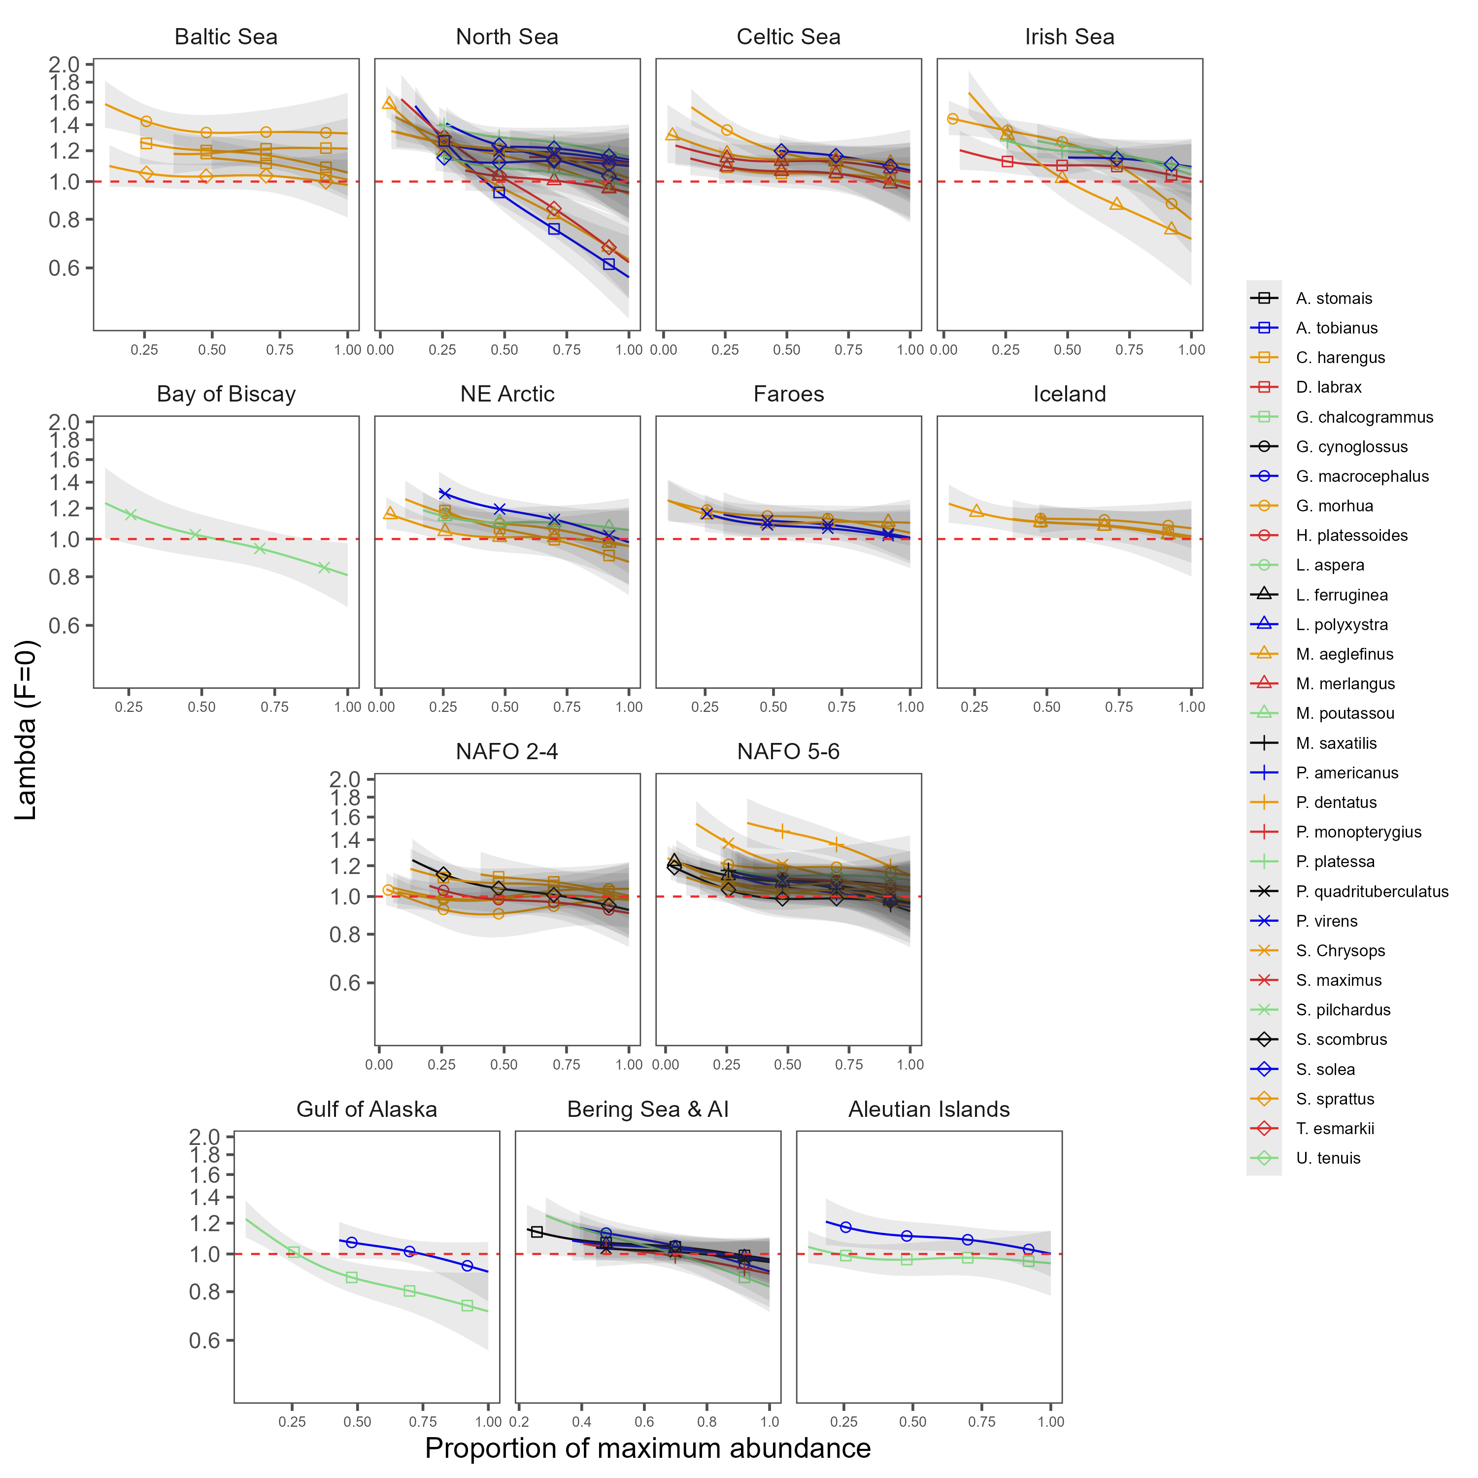

Figure A. Density dependence of $λ_{F=0}$ for each stock in the analysis plotted regionally.

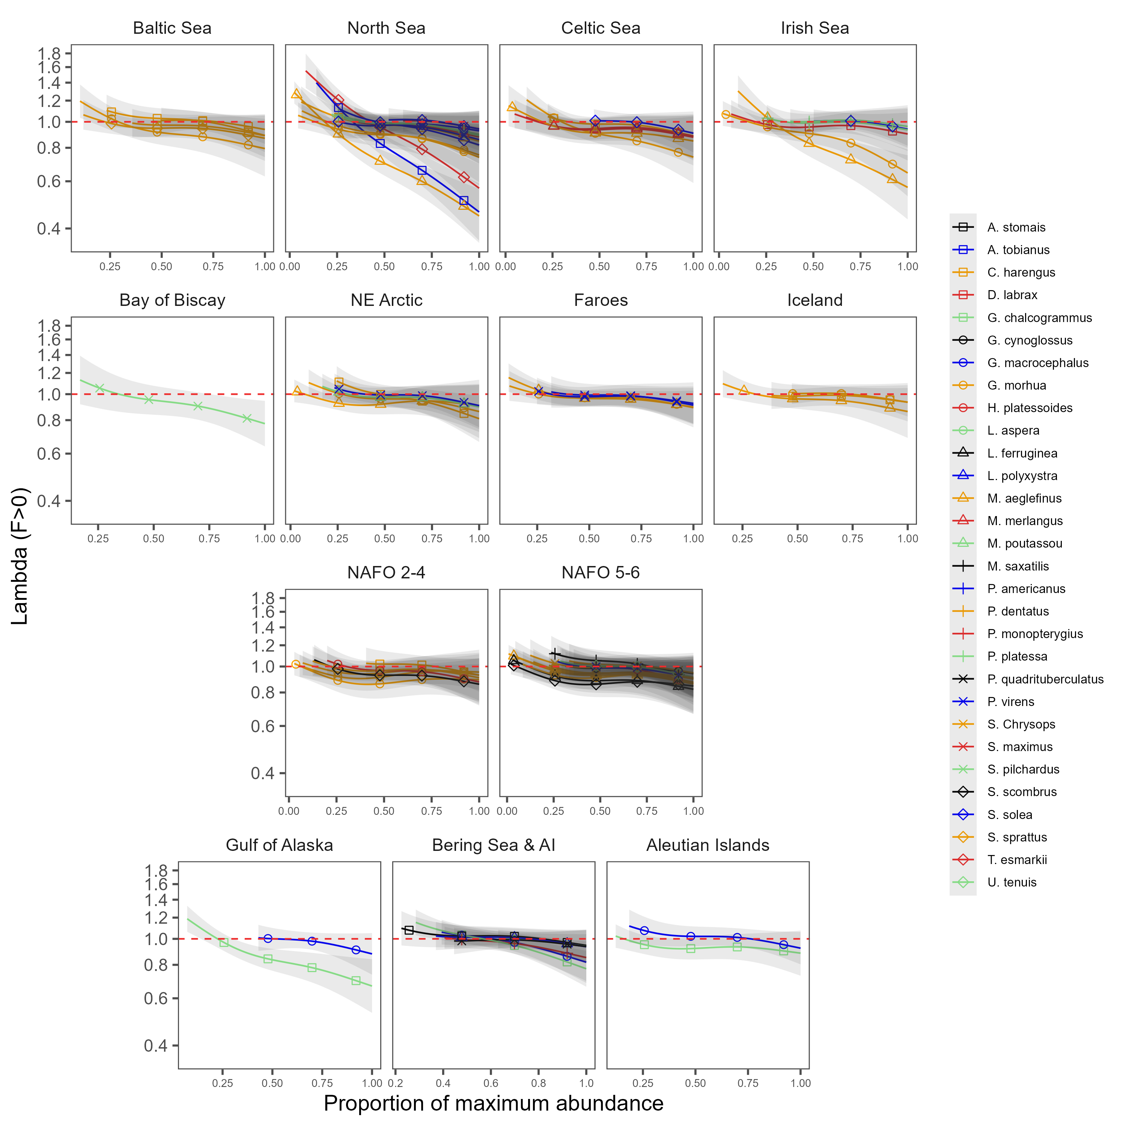

Figure A. Density dependence of $\lambda_{F&gt;0}$ for each stock in the analysis plotted regionally.

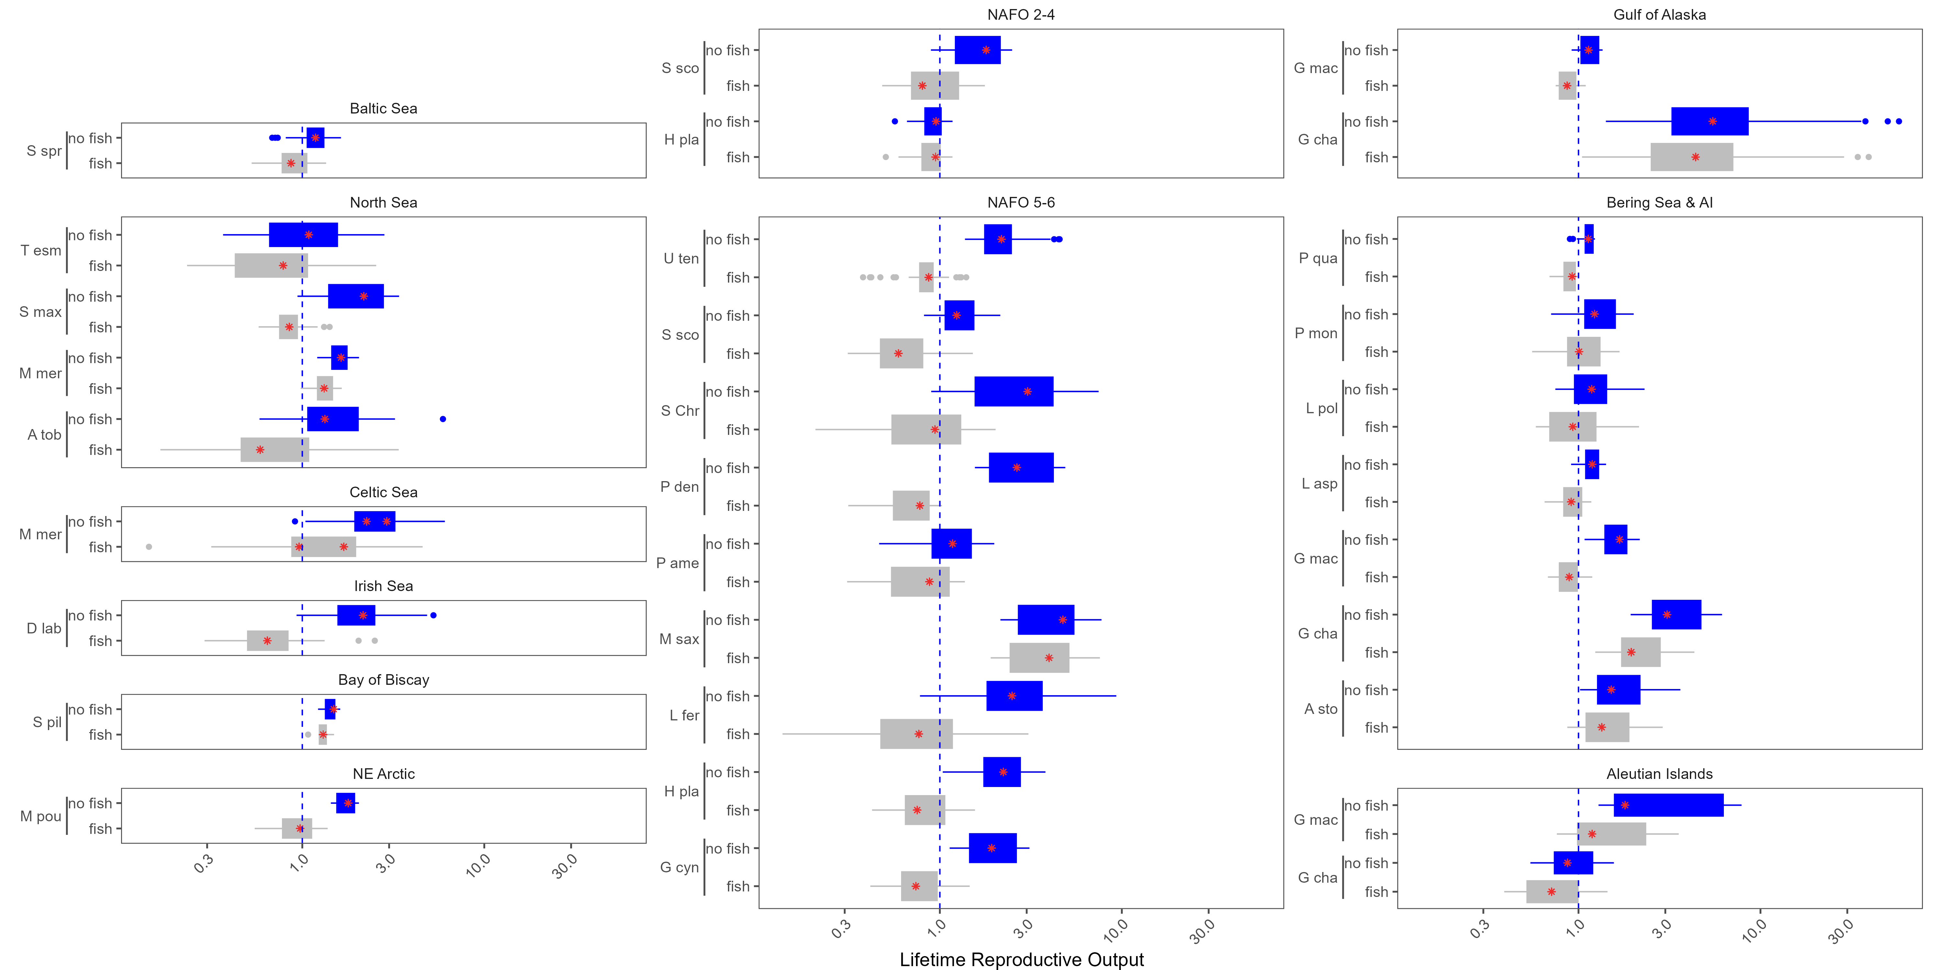

Figure A. $R_{0}$ estimates for each stock of G. morhua, M. aeglefinus, P. virens, C. harengus, P. platessa, and S. solea.

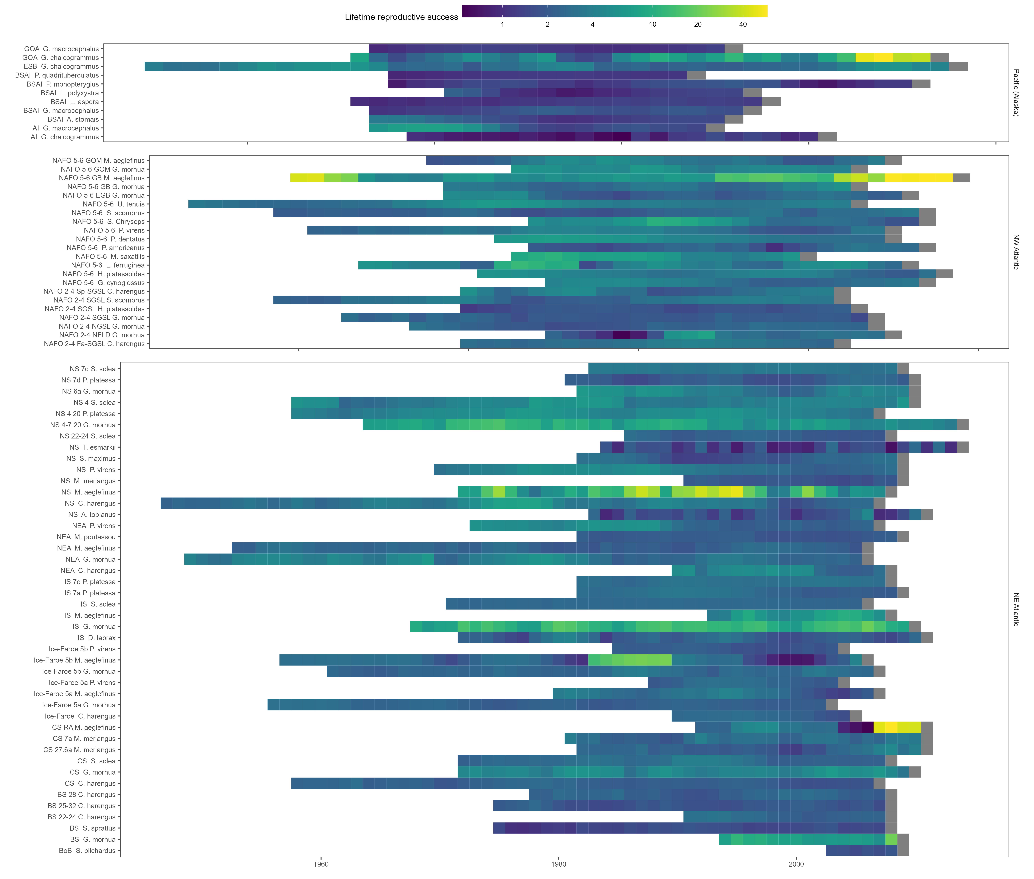

Figure A. $R_{0}$ estimates for every cohort for each species excluding the effects of fishing.

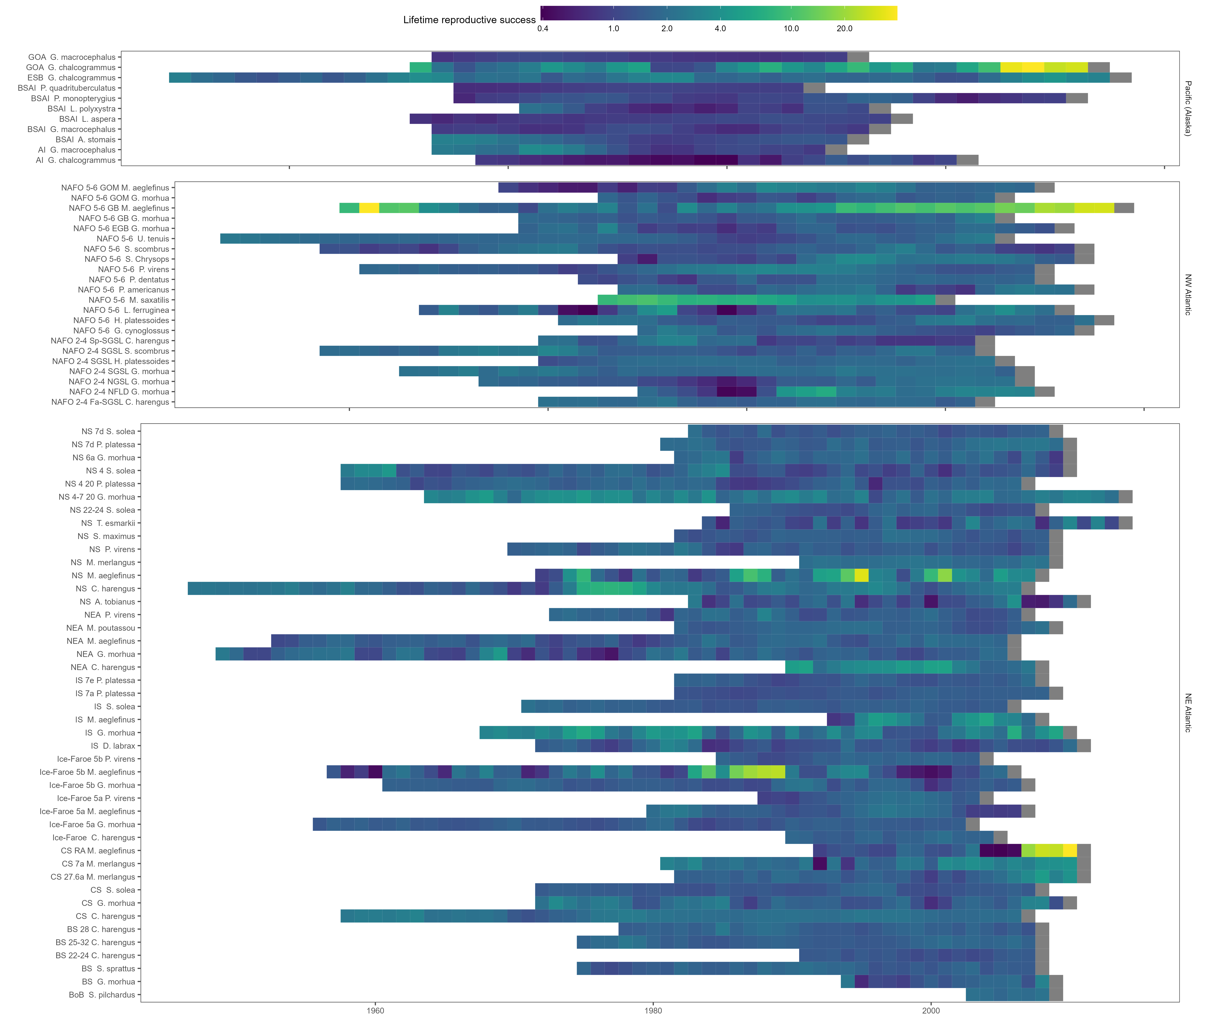

Figure A. $R_{0}$ estimates for every cohort for each species including the effects of fishing.

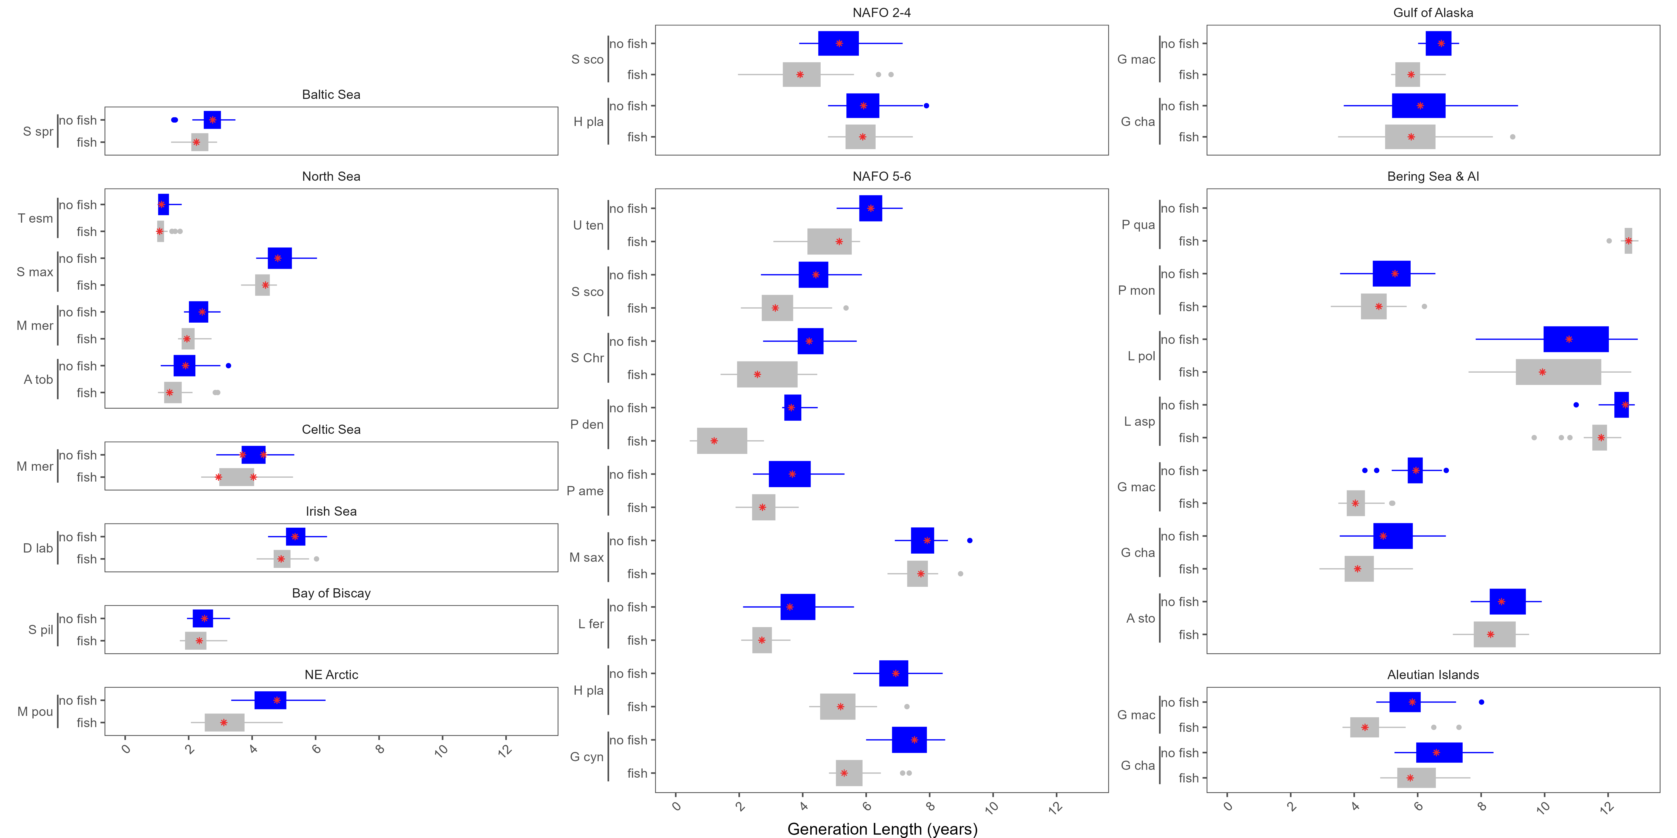

Figure A. Generation length estimates for each stock of G. morhua, M. aeglefinus, P. virens, C. harengus, P. platessa, and S. solea.

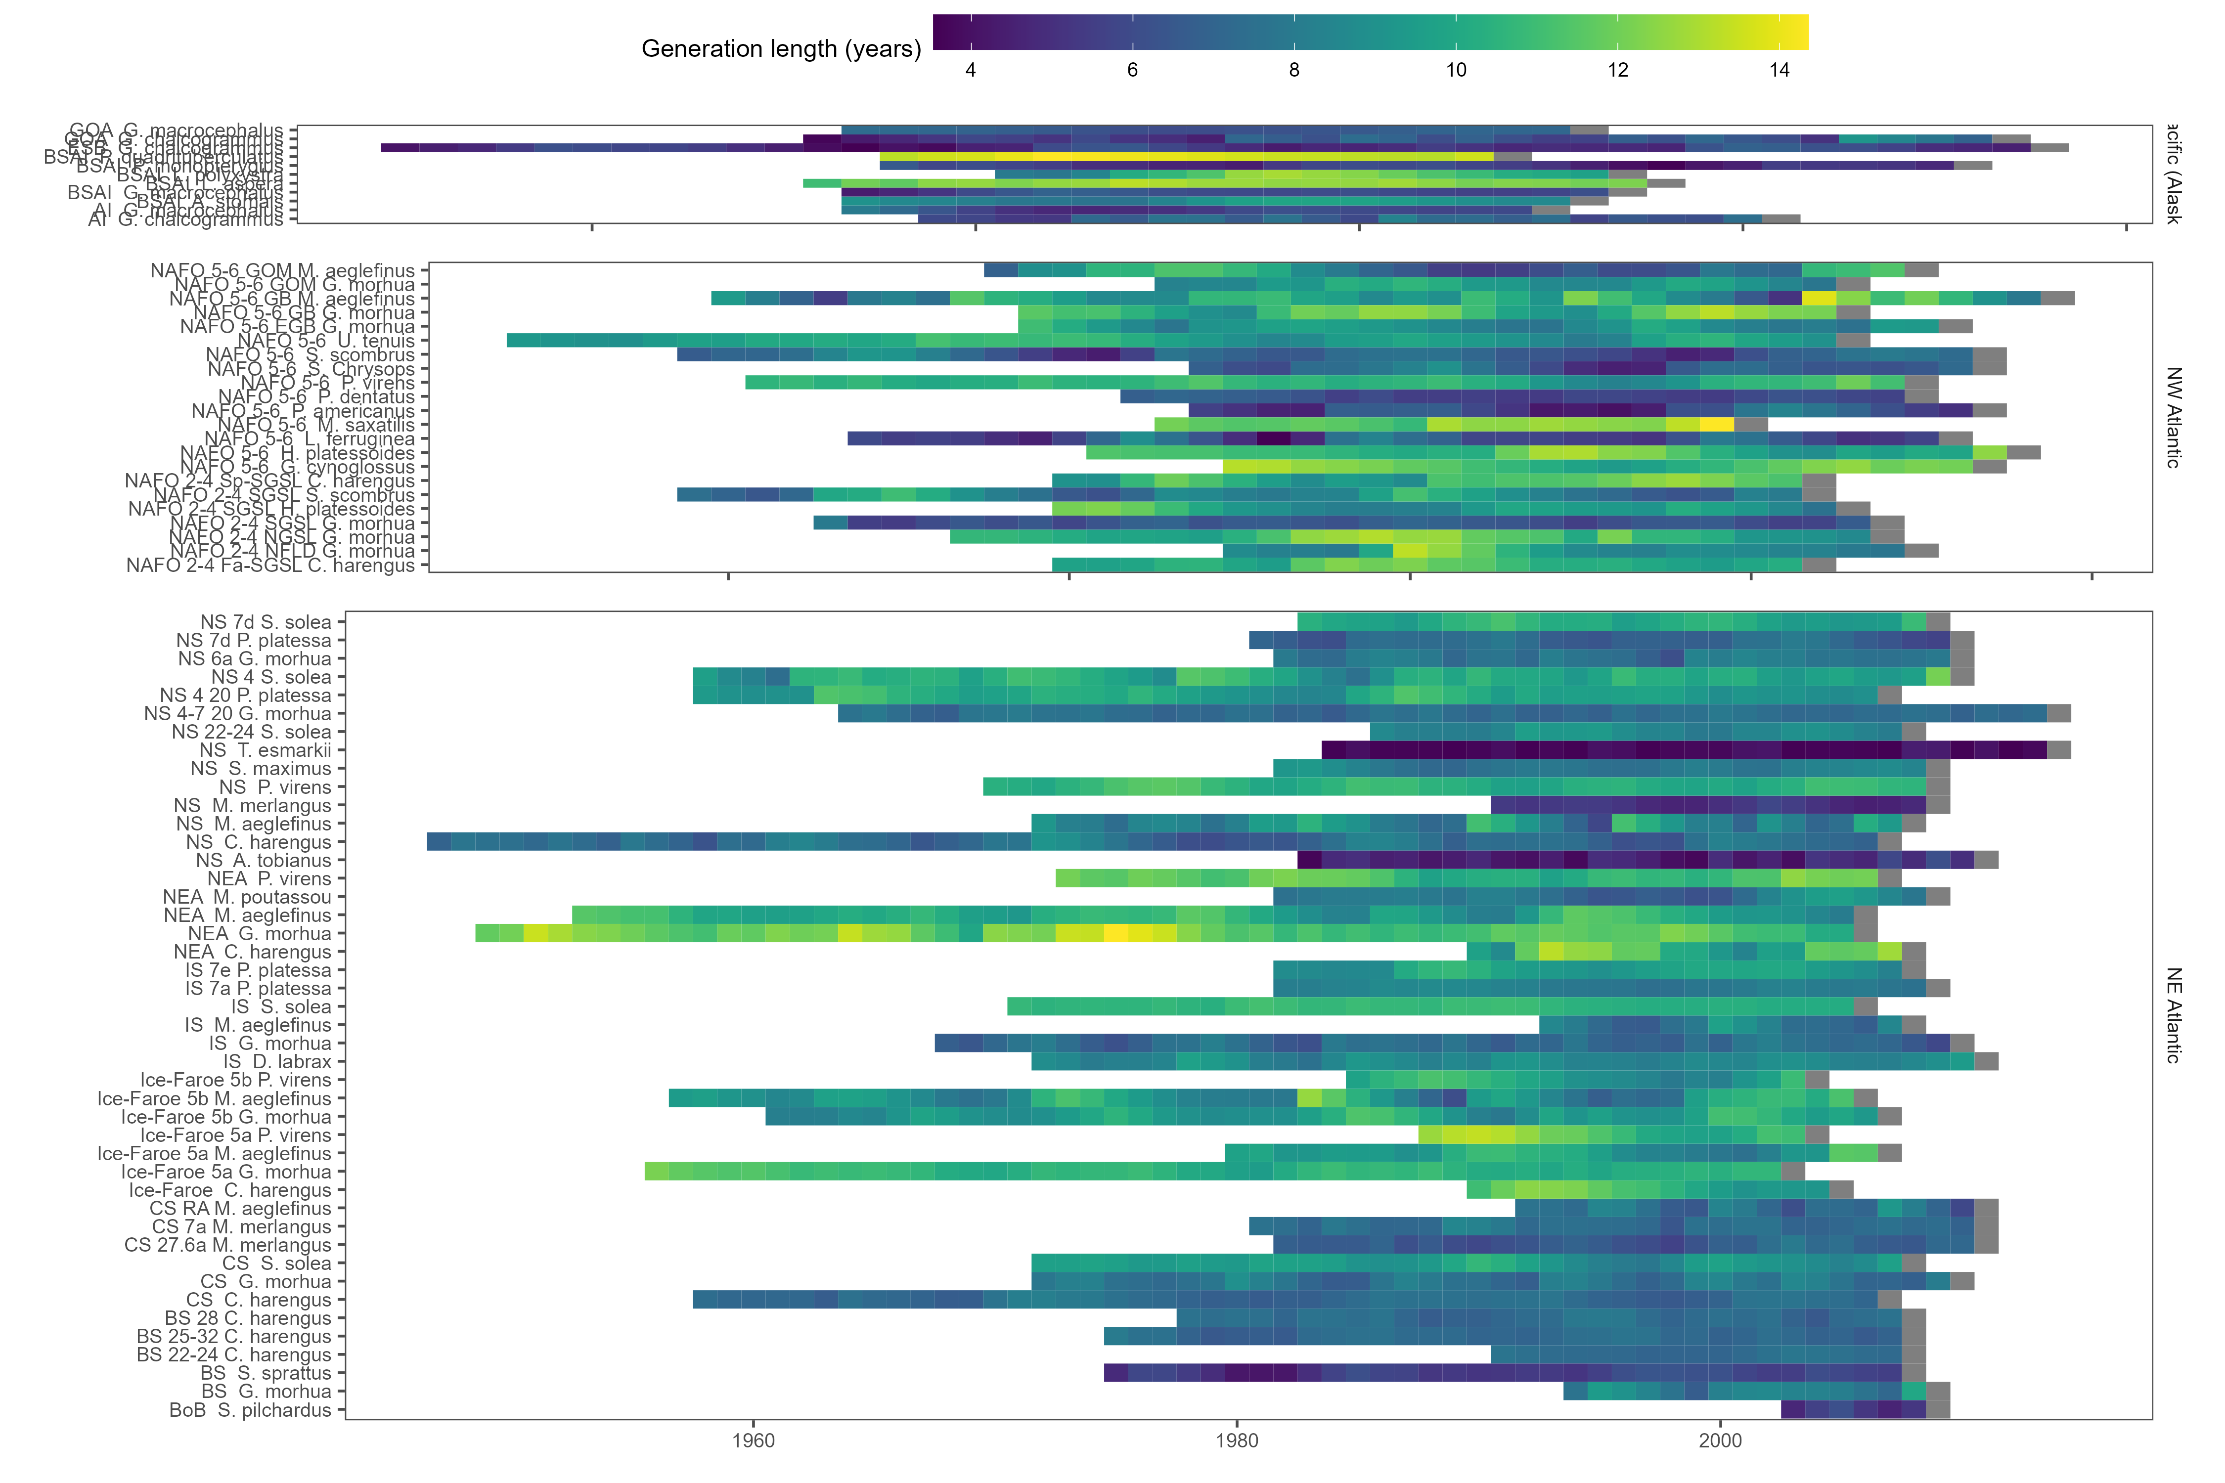

Figure A. Generation length estimates for every cohort for each species excluding the effects of fishing.

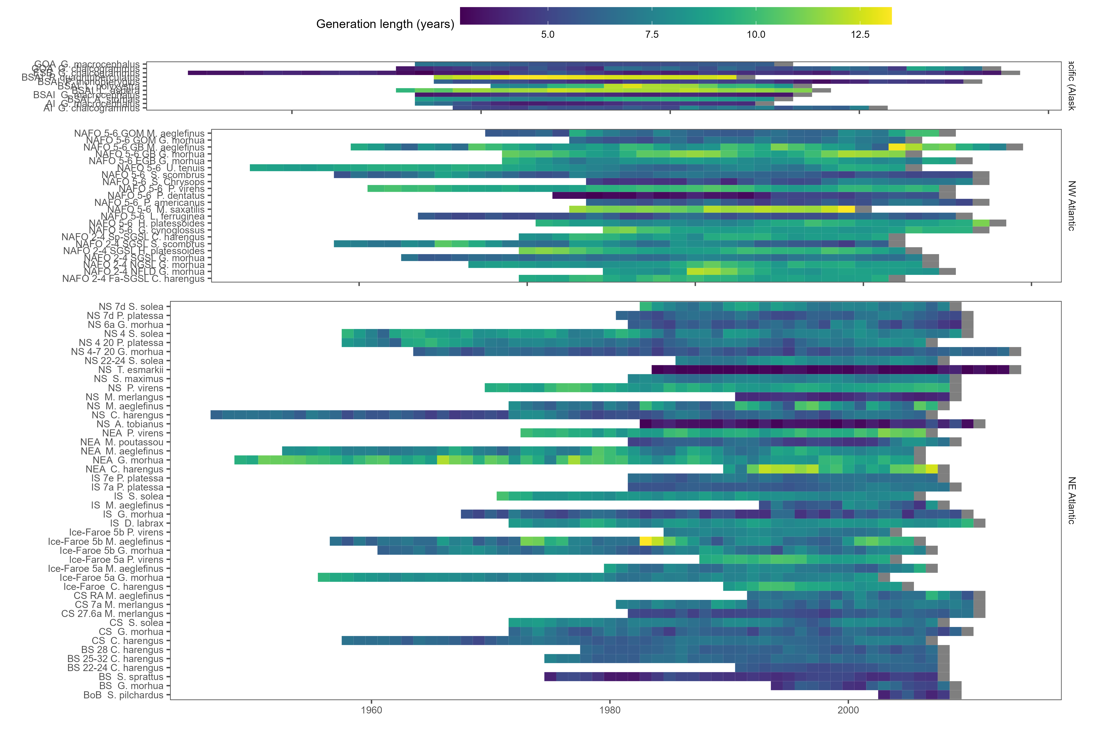

Figure A. Generation length estimates for every cohort for each species including the effects of fishing.

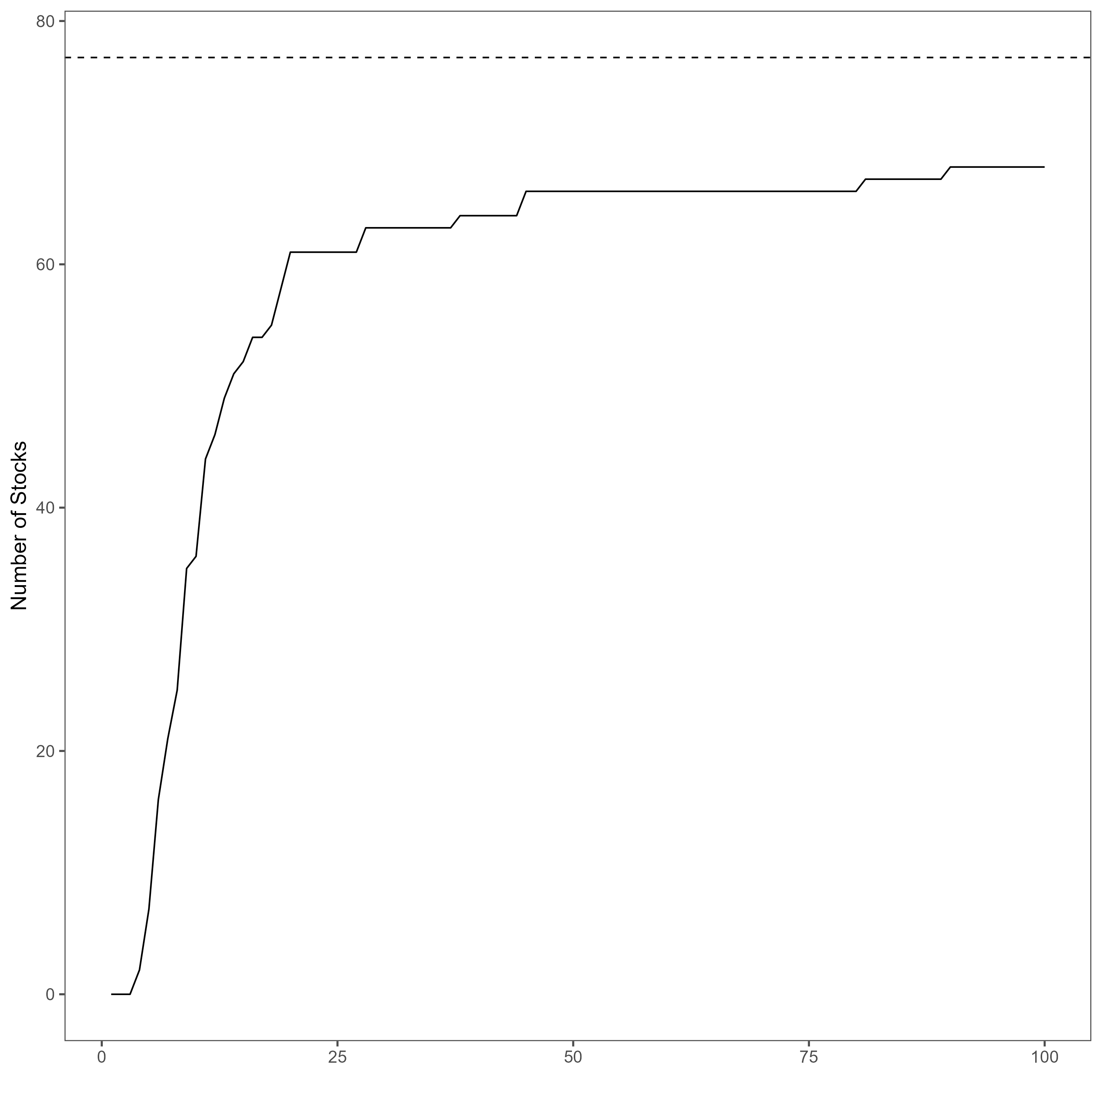

Figure A. The number of stocks which doubled in size by a given year with no fishing mortality The dashed line represents the 77 stocks in the analysis.